Indoor Smart Plant Monitoring System

Nishant Gujar
School of CET
MIT World Peace University
Pune, India
nishant9565@gmail.com
Kaustuh Bhujbal
School of CET
MIT World Peace University
Pune, India
kaustubhbhujbal9@gmail.com
Balaji M. Patil
School of CET
MIT World Peace University
Pune, India
balaji.patil@mitwpu.edu.in
Shreyas Bedekar
School of CET
MIT World Peace University
Pune, India
2012shreyasbedekar@gmail.com
Zaid Inamdar
School of CET
MIT World Peace University
Pune, India
thespeedster27@gmail.com

Abstract— nowadays gardening has become very much important and it now popularly known to increase fitness as well healthiness of life. The indoor gardening is high in demand as it provides many health benefits by filtering the toxins which decreases probability of sickness such as inconvenience or hassle, mental illness and many such disorders. However the most of people now have moved in apartments, were there are lot of difficulties for people to grow their own outdoor or indoor garden and indoor plants adjoining to their home and also people don’t want to spend that much time to take care of their plant. The collaboration of Internet of things (IoT) with image processing to monitor the health of the plant is a crucial way to minimize the issues faced by the people to grow indoor plants. In this proposed paper, an arduino which an important IoT tool is projected which updates the parameters like soil moisture, air quality, light, temperature, water level in real time database and a deep learning image processing module is used to detect the disease of the plant. Thus, identifying the disease and identifying the surrounding parameters to monitor and to help to grow plant more efficiently for better production.
Keywords— Automation, Internet of things, Image processing, Health monitoring

Introduction
Agriculture is one of the most important and major profession or occupation since many years throughout the world. Though it’s a primary occupation from many years but still there is intervention of manual techniques for the development of the farm. The plant monitoring system has a main job for the rapid development of the plants by controlling the climate parameters which will impact the growth of the plants and their production. Earth inhabitants rate is increasing and is anticipated to reach 9.10 billion by 2052 so the availability of the land will be decreased ad due to this it is important to develop alternative farming technique like indoor gardening. In today’s world most of people have moved in bungalows, and apartment and there are a lot of difficulties faced by people to develop indoor plants adjoining to their home and due to ongoing covid19 pandemic people have hardly moved outside and they have started preferring indoor gardening for growing and developing the plants and thereby for replacing the human operator and minimizing the problems faced while indoor gardening, where the plant grows inside the house and the user can fully witness its growth and doesn’t have to worry about whether plant is infected or not. Thus we have proposed a system which will monitor indoor plants and will help to provide necessary factors for the growth of indoor plants which is the advanced version for systems or projects that were proposed earlier as it works on all the disadvantages of the previous system and tries to overcome it. All this information about the sensor data collected as well as the image processing output is been provided to the user through smart phone and this automated system will reduce man power and thereby minimize the error. This work collaborates IoT and image processing to monitor growth of the plant and to sense and update the necessary environmental factors.

Literature Survey
There are a lot of previous projects that are done in this domain by distinct people and researchers. Using this automation in the domain of agriculture and gardening has a major job in increase of cultivation as well as decreasing the efforts needed by man i.e man power. Most of the system works on basic functionalities of plant or only on soil moisture or water requirement. The paper represented by [1] Swapil bhardwaj that is ”Automatic plant monitoring system using IoT” is the system that only focuses on the requirement of plant for water, and the other factors that influence the plant’s growth are not been taken into consideration. [2] “Smart Home Garden Irrigation System using Arduino” by S.N ishak is another example were system are only proposed for minimizing water wastage as well as usage of water but other factors regarding the plant are been ignored. Sanjay Shitole system [3] “Internet of things based indoor air quality improving system” only works on improving the air quality around the plant and doesn’t check whether the plant is growing in the right direction or not or whether the plant is getting all the needful water, light for its growth. Project developed by [4] Kawale Jayshri of “IOT based smart plant monitoring system” is one of the effective system that keep tracks of the plant and checks whether the plant is getting all its requirement fulfilled, only problem with this system is that the output or status is been displayed on a LCD display board and so the user can see the update only when he/she is present near the plants, which can be troublesome for the user. The system proposed by [5] Nikolaus Correll and team “Indoor robot gardening” is an automatic system that helps in growth of the plant and automatically fulfills all the required requirement of the plant without human operator and so prevents human errors but the system architecture is too complex to build and one more con of the system is that it is not affordable which can make the project difficult to deploy. The [6] system presented by Jayendra Kumar of “Automatic plant monitoring system and watering using NodeMCU ” works on various factors of monitoring the plant and also manage the water flow required by using a controlled motor to restrict wastage of water and focus on plant’s growth, but the system does not verify if the plant is getting enough sunlight or if the environment around the plant is good or not because the plant should be never be kept at a cool or damp place where it will be difficult for it to get light. The system proposed by [7] Jeremy Maxey Vesperman of “Smart Plant Life Monitoring System” is also an effective system keep track of the plant and help in growth of the plant, the problem that the user can have with the proposed system is that the updates or notification about the plant are been sent on email, which can be difficult for some user to handle or some of them don’t know how to use that application. Byoungwook Min and his team presented system on [8] “A Smart Indoor Gardening System using IoT Technology” which is another successful project in keeping track of the plant’s health and helping the plants in growth, the problem faced in this proposed project is that there is no method for the user to inspect the condition of the plant when he/she is not present home.

Proposed Methodology
The proposed model will help to grow indoor plants efficiently by reducing the human errors as it is a fully automated which will mainly work in three phases to ensure that the plant is in a good condition and it is getting all its requirements fulfilled. Thus the main three phases of the proposed model are:
- Data Collection
- Health Monitoring
- Environmental Analysis
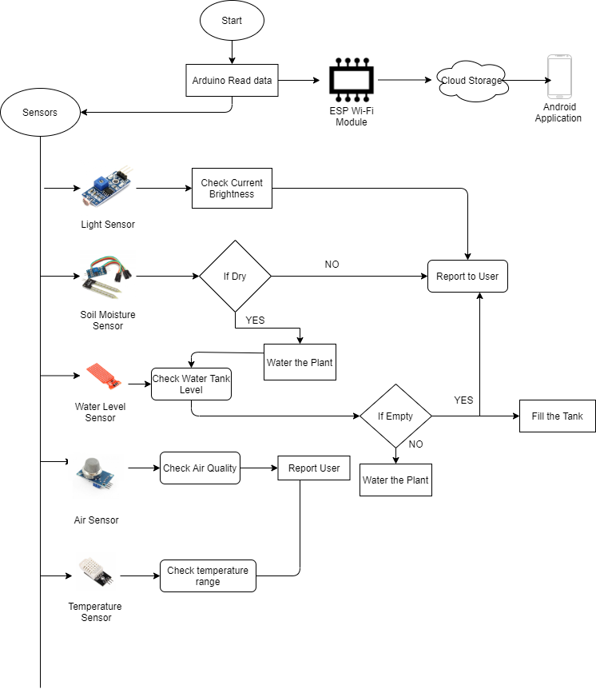
So the system will work in these phases to give you output as a perfect healthy growing plant which is also health monitored. So the first stage in the project is the collecting data phase, so this phase includes the primary function of collecting data through the sensors attached to the plant.

Figure 1: System Architecture
The sensors continuously gather the data such as the soil moisture sensors gathers information about whether the soil is currently dry or not , from which we can decide whether plant requires water or not. Then the temperature sensor will calculate the temperature around the plant which is also an important factor as the plant should not be kept at a cool or damp place. The air sensor MQ135 will detect whether the air around the plant is good or not it gives the output in bbm. The air sensor is the factor that the previous projects never implemented nor they did not focus on it, thus it plays an important job for the smooth health and development of the plant. The LDR sensor is the another sensor that plays the important role in the proposed system as the project is based on indoor plants, and sometimes as the plants are indoors they do not get sufficient sunlight for the photosynthesis which a very major process in plant’s growth, so to provide the necessary sunlight the system implements Led lights on top of the plant to provide it the necessary light required, but it is equally important to check whether the light provided to the plant does not exceed its limit or else it can damage the health of the plant. So this is where the light intensity sensor plays its role to keep the Led lights in check. After this collecting data phase comes the next phase that is health monitoring phase in which the environmental analysis of the plants surroundings is been done. In this phase the necessary action is been taken if the specified values are been surpassed which can be harmful for the plant, such as if the soil moisture indicates the mud has become dehydrated, the plant will be sprayed water, if the light sensor indicates that light intensity is high then the Led lights will be switched off, and the air sensor will gather data about the plants surrounding. Another sub module that takes place in this health monitoring phase is image processing, where using opencv and neural network the plant health condition will be verified. So the camera attached to the plant will capture image of the leaves and then send it over to the application to cross verify the image with stored dataset and give the result whether the plant is healthy of it has been infected.
The last stage of the proposed system that is the environmental analysis stage is the combination of both of the above phases mentioned above. In this phase the all the actions taken in the phase on and phase two are simultaneously done and then the data is been uploaded over the cloud server of things speak, and then later notified to the user using the android application.

Implementation
This system is built to face the problems faced to grow indoor plants automatically without any human operator, not only the system monitors the plant it also take cares of the health of the plant where image processing is been used to get accurate result about the health of the plant and other basic functionalities are been interfaced using IoT domain sensors which are then connected to the arduino to collect the information of the plant and then later all this information and result are been uploaded over the cloud and send to the android application provided to the user, where the user can view the status of the plant from anywhere and whenever he wants through the application.

Hardware Implementation
Our system is mainly focused over the growth of the plant using various detectors, such as the soil moisture sensor, temperature sensor, light intensity sensor, air sensor and all this detectors are attached to the arduino using breadboard to check the changes in surroundings of the plant to keep track of the status of plant.

Microcontroller:Arduino Uno
In our proposed system Arduino is been used as microcontroller to take control of all the sensors as well to gather the information from the sensors and then check the information with given threshold values.

Soil mositure sensor:
The role of the soil moisture sensor is to check the status of the plant’s soil, whether the soil is fully dried or it is still wet. We can decide the condition of plant depending upon the output compared with the threshold.

Light Intensity sensor:
The light intensity sensor’s task it to keep in check the intensity of the Led light that positioned at the top of the plant. The range of the sensor is 0 to 65535lx.

Temperature sensor:
The job of the temperature sensor is constantly checking the surrounding temperature of the plant, and check whether the plant is stored in cool place.
The range of the sensor is around 0 to 70 degree Celsius

Air Sensor:
The proposed system uses MQ135 sensor to detect the air around the plant, it can detect 10 to 300 ppm.

Water level sensor:
If the soil moisture indicates then it is necessary to water the plant, but another condition to check is whether there the tank is empty or not which is been done by water level sensor.

Software Implmentation
Our proposed system uses Image processing for health monitoring of the plant which comes under the software implementation of our project. We have implemented this using opencv python which is most preferred language for performing machine learning, deep learning and artificial intelligence.

Image processing :
To keep the plant healthy and prevent it from getting infected by any disease or fungal infection we have implemented image processing where the captured image of the plant is compared with the stored image dataset and the result is then updated to the user through the android application.
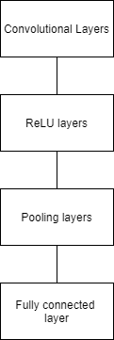

Figure 2: Steps for Image processing

Convolutinal Layer:
These are the major steps used in convolutional neural networks. It is the simple output of a filter to a process output in a trigger. It is the method to understand a big number of filters in parallel specific to a training dataset under the condition of a specific predictive modeling problem.

ReLU Layers
ReLU means rectifier unit, it is most similar method deployed trigger activity for the result of the CNN neuron. It nota different at start, which makes it difficult to implement with back propagation preparation. Mathematically described as:

Pooling layers:

The Pooling layer are used to reduce the dimension of the attribute charts. Thus, it decreases the number of parameters needed tounderstand and the quantity of computation performed in the network. Thus it sums up the attribute that present in a region of attribute chart produced by a convolutional layer.

Fully Connected layer:
The fully connected layer is very easy, where we insert into onward neural networks. Fully connected layer is one of the last forms in the network. The data given to the fully connected layer is the result from the final pooling or the convolutional layer, which is the flattened and then given to fully connected layer.

1] CNN classification:
CNN or convolutional neural network (CNN) is deep learning neural network. Firstly, it takes the input layer which is grayscale image. Then the output which is in binary or multi-class label. The hidden layers consisting of convolution, ReLU (rectified linear unit) layer, the pooling layers are fully connected to neural network.

Expirmental Results
The training dataset of images consists of 1100 images in which there about 600 images of healthy for validation and about 500 images of unhealthy plant or infected leaves or diseased plant leaves images. Initially the plant is connected with soil moisture sensor, dht11 sensor, temperature sensor, light intensity sensor and the air sensor. All these sensors are connected with Arduino through the breadboard.
Soil moisture sensor detects the condition of the soil whether is dry or wet, as well as the dht11 sensor constantly checks up upon the temperature around the plant. The light intensity sensor performs the role to restrict high intensity of Led lights. The air sensor that is the MQ135 sensor checks upon the air around the plant and gives digital output to the Arduino.
The health monitoring phase consists of image processing which is done using opencv python. The process is been performed in total of 4 steps from the output we get the result about plant’s health condition. It consists of three major components that are the preparing, validation and the evaluating the images, from which the output is been decided. The process uses CNN classifier algorithm using which we get precise accuracy from the deep learning model. Then the result that we get through the deep learning is then send over to the cloud server and then send over to the user through the android application.
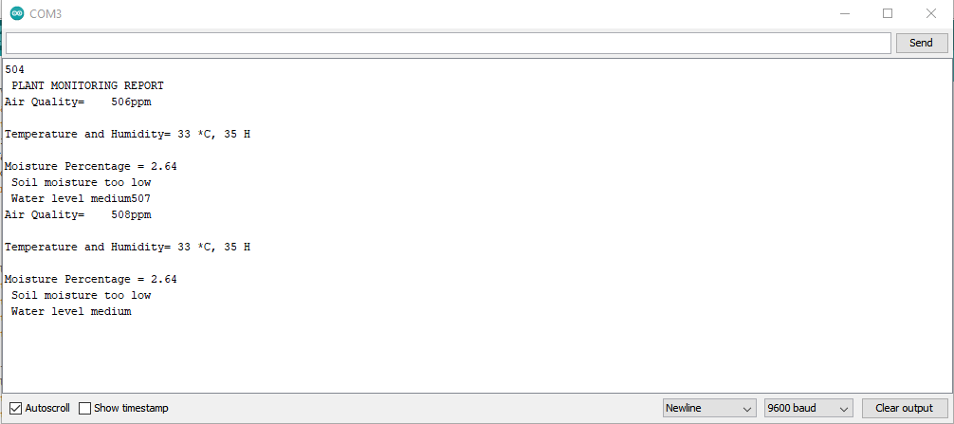
Figure 3: Data collection and output of sensors
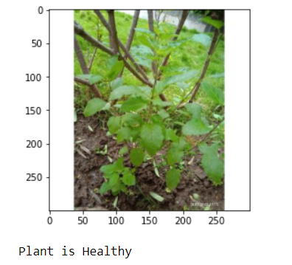
Figure 4: Image processing output

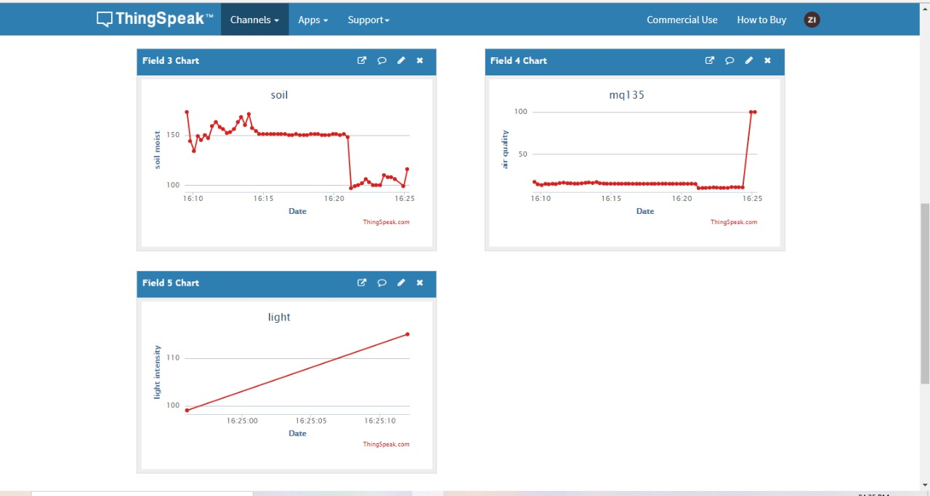

Fig 5: Thingspeak server data stored

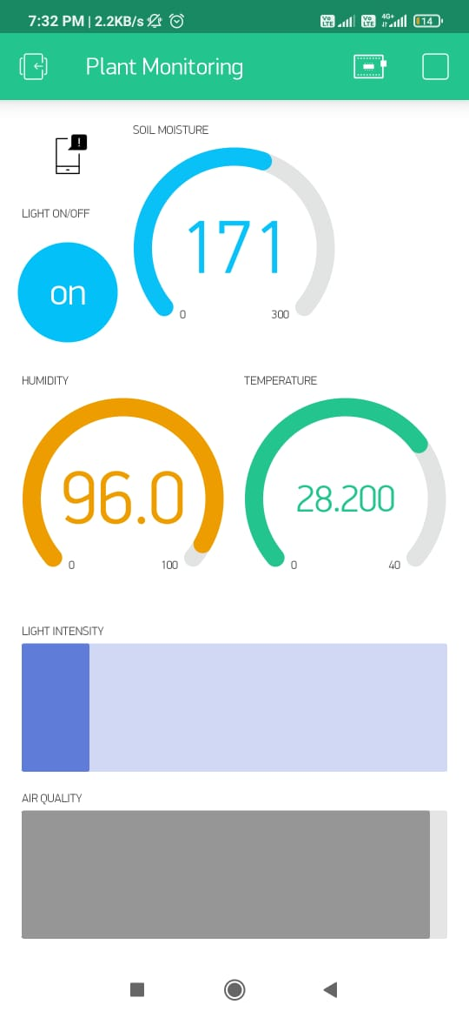
Figure 6: Android Application Screenshot

Figure 7: CNN classification Accuracy /Losses
Epoch | Deep Learning Training
Epoch | Loss | Accuracy | Validation Loss | Validation Accuracy
1 | 0.5576 | 0.7649 | 0.4145 | 0.8571
2 | 0.4221 | 0.8332 | 0.3794 | 0.8520
3 | 0.3999 | 0.8516 | 0.3691 | 0.8552
4 | 0.3619 | 0.8663 | 0.3775 | 0.8517
5 | 0.3479 | 0.8752 | 0.3650 | 0.8639
6 | 0.3270 | 0.8888 | 0.3657 | 0.8579
7 | 0.3126 | 0.8997 | 0.3688 | 0.8708
8 | 0.2980 | 0.9087 | 0.3678 | 0.8648
9 | 0.2832 | 0.9168 | 0.3668 | 0.9628
10 | 0.2608 | 0.0243 | 0.3801 | 0.8616

Acknowledgment
The authors would like to thank Prof Dr. B M Patil, Prof. Pratik Soygoankar and Prof. Sharmishta Desai for giving us the much needed help by making every component of the project accessible as well as providing workplace to talk through and execute the proposed project. Also, the Authors appreciate the enlightenment on the chosen domain.

Conclusion
This proposed project keeps an eye on different gardening attributes and informs the user about the status of the plant through the tablet or phone using android application. It also assists to solve many difficulties that occur in the current systems for plant monitoring and maintaining gardening system. It assists in taking care of the indoor plants in an efficient way. The smart system will provide the basic support with the help of various sensors embedded in the system which will improve the health of the houseplants. It lowers the responsibility of the owner by connecting technology with the plants and increase the health of the plant, thereby allowing it to grow in a good way. The gentle reminders for taking care of the houseplants will result in increasing their life span. By executing android application it connects the app in the mobile to a user who can check the condition or status of the plant solitarily. It will be much easier to take care of your plants and create a healthy environment for you as well as the environment. The plan to develop an automatic maintained system to keep track of houseplants and interact with them using the collaboration of various technologies together was conceptualized and produced in a well- controlled and objective environment. The main edge of this smart indoor gardening system is that the user can check the status of garden using the world wide web from far long distances during time off or whenever necessary.

Future Work

The system can be built on large scale that can be used in green house projects, which will be very useful for monitoring the plants on a large scale with the required amount of resources for each plant, and growing the plant in the same soil will be very economical for the project. Another up gradation that can be used for smooth functioning of the project us using raspberry pi as the module for gathering information from the detectors and uploading to the cloud, as it has built in Wi-Fi module no external chip or module is required for connection to cloud server. Lastly, more advanced model training can be done for image processing for more accuracy decision about health condition of plant.

References

- S. Bhardwaj, S. Dhir and M. Hooda, "Automatic Plant Watering System using IoT," 2018 Second International Conference on Green Computing and Internet of Things (ICGCIoT), 2018, pp. 659-663, doi: 10.1109/ICGCIoT.2018.8753100.
- S.N. Ishak, N.N.N.Abd Malik, N.M. Abdul Latiff, N. Effiyana Ghazali, M. A. Baharudin, Smart Home Garden Irrigation System Using Arduino, 2017 IEEE 13th Malaysia International Conference on Communications (MICC), 28-30 Nov. 2017, The Puteri Pacific, Johor Bahru, Malaysia
- S. Shitole, D. Nair, N. Pandey and H. Suhagiya, "Internet of Things Based Indoor Air Quality Improving System," 2018 3rd International Conference for Convergence in Technology (I2CT), 2018, pp. 1-4, doi: 10.1109/I2CT.2018.8529813.
- Kawale Jayashri, Sanjay More, Akshay Bankar, Ganesh Dongre, Pooja Patil, I0T BASED SMART PLANT MONITORING SYSTEM International journal of advance research in Science and Engineering, volume -07, special issue no.3, April 2018
- Correll, Nikolaus & Arechiga, Nikos & Bolger, Adrienne & Bollini, Mario & Charrow, Ben & Clayton, Adam & Dominguez, Felipe & Donahue, Kenneth & Dyar, Samuel & Johnson, Luke & Liu, Huan & Patrikalakis, Alexander & Robertson, Timothy & Smith, Jeremy & Soltero, Daniel & Tanner, Melissa & White, Lauren & Rus, Daniela. (2010). Indoor robot gardening: Design and implementation. Intelligent Service Robotics. 3. 219-232. 10.1007/s11370-010-0076-1.
- J. Kumar, N. Gupta, A. Kumari and S. Kumari, "Automatic Plant Watering and Monitoring System using NodeMCU," 2019 9th International Conference on Cloud Computing, Data Science & Engineering (Confluence),2019, pp. 545-550, doi: 10.1109/CONFLUENCE.2019.8776956.
- J. Maxey-Vesperman, Z. Goldasich and G. Tewolde, "Smart Plant Life Monitoring System," 2019 IEEE 16th International Conference on Smart Cities: Improving Quality of Life Using ICT & IoT and AI (HONET-ICT), 2019, pp. 238-240, doi: 10.1109/HONET.2019.8907989.
- Min, B., & Park, S. J. (2018). A smart indoor gardening system using IoT technology. In G. Yi, Y. Sung, J. J. Park, & V. Loia (Eds.), Advances in Computer Science and Ubiquitous Computing - CSA-CUTE 17 (pp. 683-687).
- M. I. Pavel, S. M. Kamruzzaman, S. S. Hasan and S. R. Sabuj, "An IoT Based Plant Health Monitoring System Implementing Image Processing," 2019 IEEE 4th International Conference on Computer and Communication Systems (ICCCS), 2019, pp. 299-303, doi: 10.1109/CCOMS.2019.8821782.
- Priya, C.G., AbishekPandu, M., & Chandra, B. (2017). Automatic plant monitoring and controlling system over GSM using sensors. 2017 IEEE Technological Innovations in ICT for Agriculture and Rural Development (TIAR), 173-176.
- P. Varalakshmi, B. Y. Sivashakthivadhani and B. L. Sakthiram, "Automatic Plant Escalation Monitoring System Using IoT," 2019 3rd International Conference on Computing and Communications Technologies (ICCCT),2019, pp. 212-216, doi: 10.1109/ICCCT2.2019.8824969.
- Rawal, Kush and Gabrani, Goldie, IoT based Computing to Monitor Indoor Plants by using Smart Pot (March 28, 2020). Proceedings of the International Conference on Innovative Computing & Communications (ICICC) 2020
- Nikita Bakhtar, Varsha Chhabria, Iptisaam Chougle, Harsha Vidhrani, Mrs. Rupali Hande, IoT based Hydroponic Farm, International Conference on Smart Systems and Inventive Technology (ICSSIT 2018)
- Elangovan, Ramkumar & Santhanakrishnan, Nagarani & Rozario, Roger & Banu, Arjuman. (2018). Tomen:A Plant monitoring and smart gardening system using IoT. International Journal of Pure and Applied Mathematics. Volume 119.
- Vijayshree . T, A.Gopal, “Comparison Procedure for the Authentication of Basil (Ocimum tenuiflorum) leaf using Image Processing Technique”, IEEE ICCSP 2015 conference.
- Sachin D. Khirade, A.B. Patil , “Plant Disease Detection Using Image Processing”, 2015 Internatinal Conference on Computing Communication Control and Automation.
- Yin Min Oo, Nay Chi Htun, “Plant Leaf Disease Detection and Classification using Image Processing”, Internatinal Journal of Research and Engineering Vol. 5 No. 09 September –October 2018

- Birgit Penzenstadler, Jayden Khakurel, Carl Jason Plojo, Marinela Sanchez, Ruben Marin and Lam Tran, “Resilient Smart Garden – Exploration of a Blueprint”, Information and Communication Technologies(ICT) for Sustainability.

[19] https://www.researchgate.net

[20] https://www.ieee.org/

[21] https://www.researchgate.net/

